Not Just Weird Weird，but Censorship Weird -- There Is Only Semaglutide，no Ozempic

-
Advertisement
Shop lemonmama 檸檬媽媽 tokens (serial numbered) on eBay.com
https://www.ebay.com/usr/morjas-0
-

This is weird.
Not just weird weird, but censorship weird.
Taboo level of weird.
The kind of weird that makes you want to know why.
Why this is taboo.
Who is censoring this.

Searched the word ‘ozempic’ on wikipedia.
But there is no entry for that.
It redirect to ‘semaglutide’ though.
Did ‘find on this page’ search for the word ‘ozempic’ on that page.
But the word ozempic doesn’t appear anywhere on that page either.
See screenshot here below:

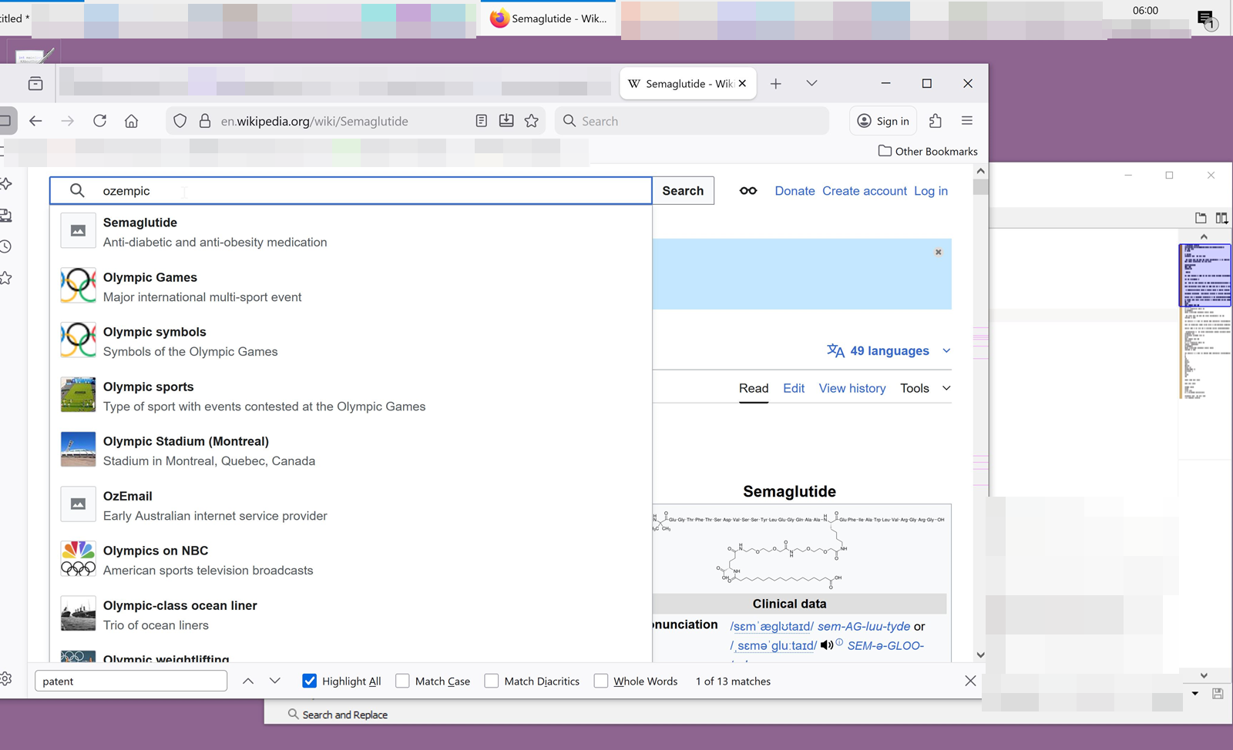

So I’m assuming that folks will get sued if they mention the word ‘ozempic’ here or anywhere.
But I’m making that up.
So I guess I’ll get sued too.
Unless I made that up.
So but time to research, time to find out why and who this is redirected/censored/taboo.

Whoo! just stumbled upon this. When trying to glean the wikipedia URL.
It initially seems to say there is a whole category of wikipedia pages that are called “Category:Redirects from trade names of drugs”
Wow.
I feel like I am neo and just woke up from the matrix.

https://en.wikipedia.org/wiki/Neo_%28The_Matrix%29

And so here are some links from wikipedia talking about “Category:Redirects from trade names of drugs” here:

https://en.wikipedia.org/w/index.php?title=Ozempic&redirect=no
https://en.wikipedia.org/wiki/Category:Redirects_from_trade_names_of_drugs
https://en.wikipedia.org/wiki/International_nonproprietary_name

This started off here in this blog post here.
But then stay tuned, because this will continue next off on a separate blog thread here:
‘internet search DMing cold-caller’

See also:
#0217 - Regarding Big Pharma
https://lemonmama.com/lemonmama/2026/0217%20big%20pharma%20real%20tv.html

~
#0219, lemonmama.com, by author Morgan Jassen, with commercial interest, 2026-04-15

